Collection Management System (CMS)

For managing collection efficiency in NBFC business effectively while using software, leverage a dedicated Collection Management System Module that automates key tasks like:

- Collection Management System
Plan to development of Collection Modules for mobile app and web based application to when ever we collect loan repayment from our customers can be directly entered by our BDM and this can be pushed to our LMS system while using API integration.

For the case non payments / less collections there could be facility to capture reason for non payments and PTP (promise to pay) date should be captured.
And further PTP visits and regular follow-ups and reasons could be stored in the system reports can developed for better tracking purpose.

- Demand vs collection tracking
Mapping customers and loan accounts to BDMs/Collection agents ensures accountability and better tracking of collections. Importing the demand report from LMS to CMS will help in:
Real-time Demand vs. Collection Tracking – Identify gaps and take corrective actions.
Agent Performance Monitoring – Measure efficiency based on assigned vs. collected amounts.
Prioritization of High-Risk Accounts – Focus on overdue accounts based on risk categories.

- Automated reminders and communication
Sending timely SMS, email, and WhatsApp notifications to customers approaching due dates, using multiple communication channels for better reach.
And also a loan repayment and reminder calls.

- Early delinquency identification & management:
Proactively identifying and contacting customers who are currently up-to-date or just became past due, but have a predicted high risk of becoming delinquent.

Some of the best practices which are used industry level:
Delinquency Stage | Recommended Action
Early-Stage Delinquency (1-30 Days Late) | Send a friendly reminder via email or phone, offering flexible payment options.
Mid-Stage Delinquency (30-60 Days Late) | Follow up with more assertive calls or written notices. Consider offering a payment plan.
Late-Stage Delinquency (60+ Days Late) | Send a formal demand letter and escalate to collections or legal action if necessary.

- Root cause analysis for non-payments:
The system should design to capture root cause analysis, providing valuable insights into the reasons behind customer payment issues. This can help us to address the root cause and improve collections.

- BDM performance tracking
Track BDMs Overdue follow-up field visits in real-time using while using GPS and mobile apps, monitor performance metrics, and assign cases based on location and expertise.
Digital Collection process.
We need to plan for digital collection through BBPS, NACH, UPI collection process. Our Bank account QR code can be displayed on Customer’s Repayment schedule.

- Integrations with LMS system.
Ensure seamless data flow between the Loan servicing and LMS platform for accurate customer information and real-time updates.

- Debt Collection Workflows:
Establish structured collection workflows with escalating actions based on delinquency stages, including personalized outreach and legal recovery options.

- Reporting and Analytics:
Generate comprehensive reports on collection performance, key metrics like recovery rates, agent efficiency, and outstanding debt to identify areas for improvement.

Incentives based on Overdue and NPA Collections:
We have to implement system calculated incentives mechanism process for especially delinquency collections.
Eg:
Overdue collection == 5 % based on incentive to BDMs
NPA collection === 10 % based on incentive collection to BDMs

With the implementation of Loan Servicing Module empowers us to maintain operational efficiency, reduce delinquency percentage, and provide borrowers with seamless experience.

Some of the sample screenshots can be used for development of CMS :
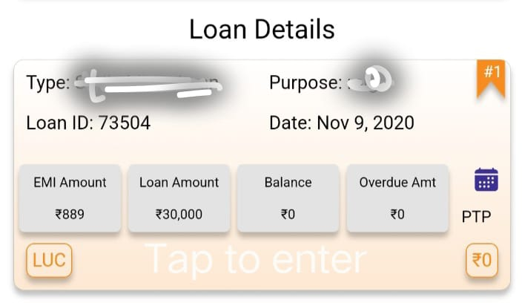

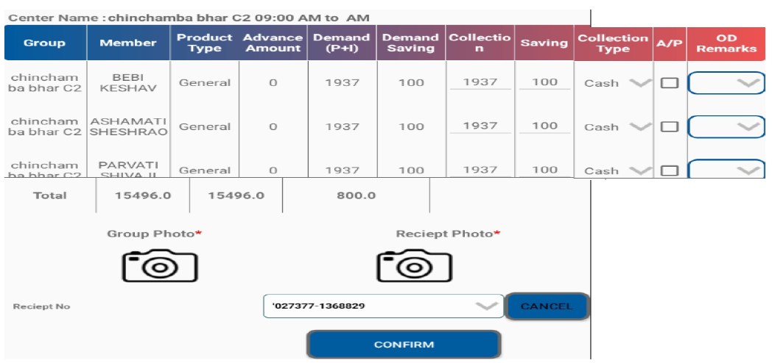
Loan collection Screen (Mobile application) entered by BDM:

Loan collection screen Web screen1:
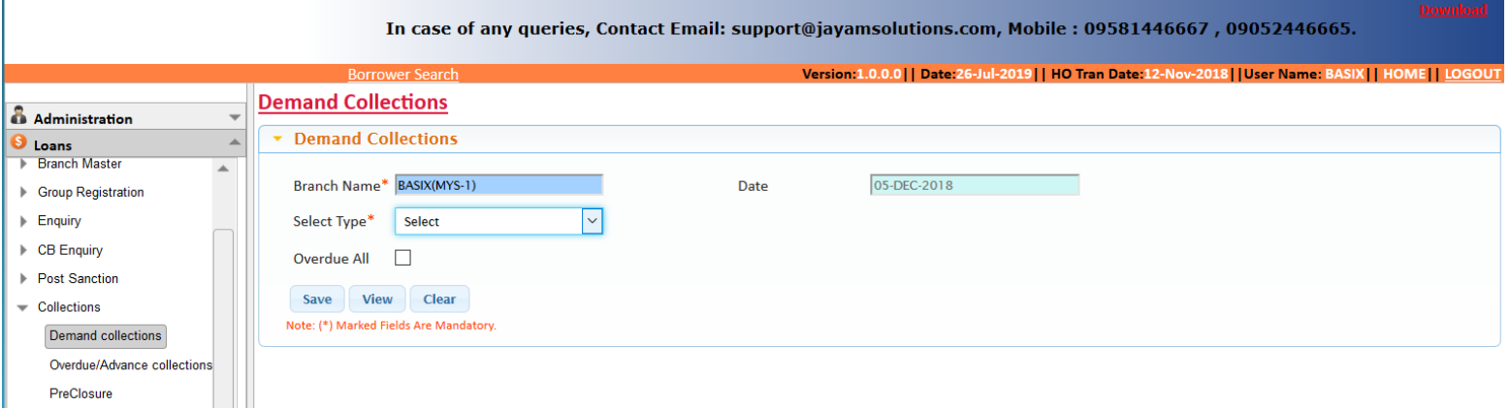
Loan collection screen Web screen2:
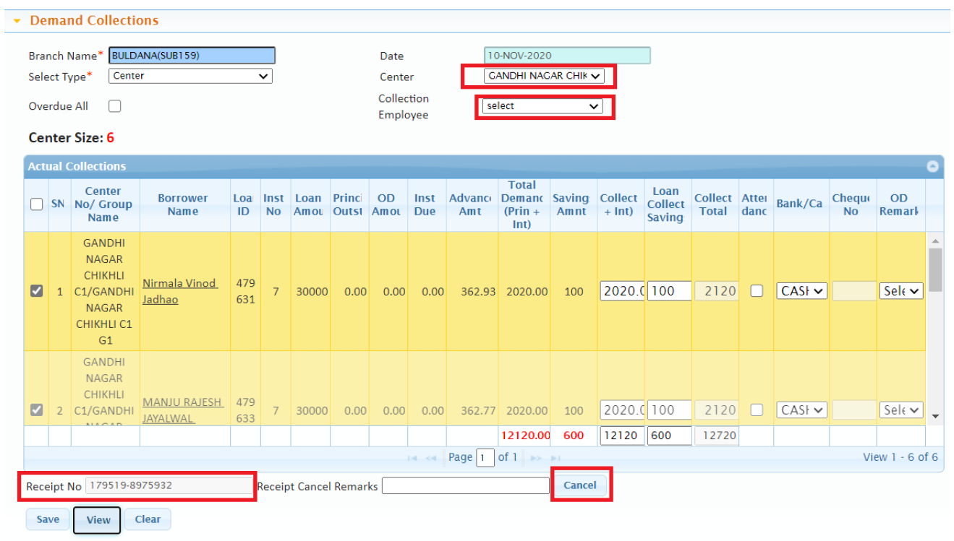

Loan collection Authorization screen done by Sr. BDM:
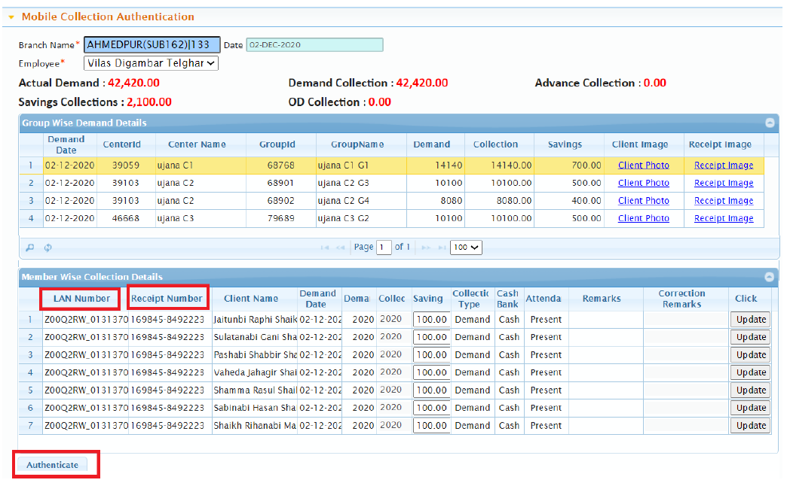
Overdue and NPA follow-up Screen:
